Multiple-choice section

|  |  |  |  |  |  |  |  |  |
| --- | --- | --- | --- | --- | --- | --- | --- | --- |
| Question | 1 | 2 | 3 | 4 | 5 | 6 | 7 | 8 |
| Answer | B | C | C | A | B | A | A | B |

Question 1 [8.1]

B

You can walk around the school and observe the number in each class.

Question 2 [8.2]

C

0, 1, 1, 2, 3, 4, 6, 7

mean =  = 3

median =  = 2.5

Question 3 [8.3]

C

 = 27

Question 4 [8.5]

A

9 balls in total, 3 of which are red: 

Question 5 [8.5]

B

Five 4s have been rolled out of a total of 30 rolls.



Question 6 [8.5]

**A**

Using a tree diagram, Sheldon has  ways of having Korny Kobs on the first day and  ways of have Korny Kobs on the second day. There are 25 outcomes possible, only one of which where Sheldon has Korny Kobs 2 days in a row. So the answer is .

Question 7 [8.7]

A

Using a tree diagram, there are 9 outcomes possible, only one where Sheldon has Korny Kobs two days in a row, so .

Question 8 [8.7]

**B**

Pr(*B* and odd) = =

Multiple-choice total marks: 8

Short answer section

Question 9 3 marks [8.1] [8.5]

**(a)** An event for which the probability is 0 is said to be *impossible*.

**(b)** The number of goals scored by each team is an example of *discrete data*.

**(c)** If a statistical graph is not skewed it is said to be *symmetrical*.

Question 10 4 marks [8.5]

: unlikely; : perhaps; : even chance; : most likely

Question 11 4 marks [8.2]

|  |  |  |
| --- | --- | --- |
| x | f | x × f |
| 30  31  32  33  34 | 15  16  6  3  1 | 450  496  192  99  34 |
| Total | 41 | 1271 |

mean =  = 31

median: 21st data value = 31

range = 34 – 30 = 4

Question 12 6 marks [8.3]

(a) mean =  = 23.8

|  |  |  |  |
| --- | --- | --- | --- |
| Distance (m) | Frequency | Midpoint | *xf* |
| 0−<10 | 3 | 5 | 15 |
| 10−<20 | 15 | 15 | 225 |
| 20−<30 | 20 | 25 | 500 |
| 30−<40 | 11 | 35 | 385 |
| 40−<50 | 2 | 45 | 90 |
|  | Σ*f* = 51 |  | Σ*xf* = 1215 |

(b)

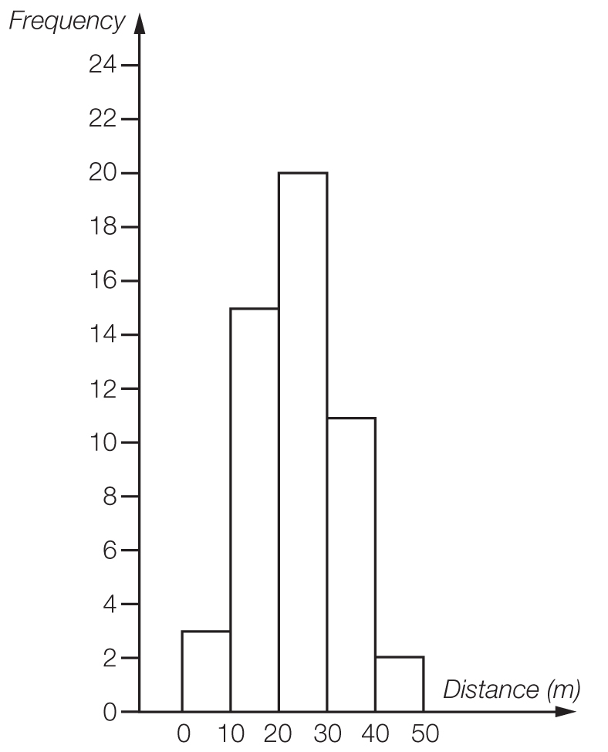

(c) The large number of values in the middle band makes this data relatively symmetrical.

Question 13 2 marks [8.5]

**(a)** Pr(Steven wins) =  = 40%

**(b)**  × 8 = 4.8

Nikki would expect to win 5 games.

Question 14 3 marks [8.5]

**(a)** Pr(neither red nor pink) =  = 

**(b)**  × 5 ≈ 0.95

1 lolly would be expected to be pink or brown.

Question 15 7 marks [8.6]

(a) (i) A and B are mutually exclusive.

(ii) A and C are not mutually exclusive.

(iii) A and D are not mutually exclusive.

(b) (i) Pr(*B* and *D*) = Pr(3, 5, 7, 11, 13, 17, 19) = 

**(ii)** Pr(*C* or *D*) =  = 

**(iii)** Pr(*A* and *B*) = 0

**(iv)** Pr(*B* only) =  = 

Question 16 8 marks [8.7]

(a)

|  |  |  |  |  |  |  |
| --- | --- | --- | --- | --- | --- | --- |
|  | R1 | R2 | R3 | Y1 | Y2 | B |
| R1 |  | RR | RR | RY | RY | RB |
| R2 | RR |  | RR | RY | RY | RB |
| R3 | RR | RR |  | RY | RY | RB |
| Y1 | YR | YR | YR |  | YY | YB |
| Y2 | YR | YR | YR | YY |  | YB |
| B | BR | BR | BR | BY | BY |  |

**(b)** Pr(RR) = 

**(c)** Pr(RR, YY or BB) = 

**(d)** Pr(neither yellow) = 

**(e)** Pr(BY or YB) = 

Short answer total marks: 37

Extended answer section

Question 17 14 marks [8.4]

**(a)** NSW: mean =  = 165.9 cm

Victoria: mean =  = 168.9 cm

**(b)**

|  |  |  |
| --- | --- | --- |
| NSW Year 9 students |  | Victoria Year 9 students |
| 6 | 12 |  |
|  | 13 |  |
| 8 6 2 | 14 |  |
| 6 5 2 2 0 | 15 | 7 9 |
| 7 7 6 4 4 4 2 0 0 | 16 | 0 0 1 1 2 2 4 4 5 5 5 6 6 7 7 7 7 7 8 |
| 9 9 6 5 4 4 3 2 0 | 17 | 2 4 4 5 5 7 8 |
| 8 2 2 | 18 | 2 6 |

**(c)** NSW: median = 164.5 cm and range = 187 – 143 = 44 cm

Victoria: median = 169 cm and range = 183 – 146 = 37 cm

**(d)** Although the mean and median are close for the two different states the range of heights is different. The shortest student comes from NSW, as does the tallest student.

Question 18 8 marks [8.6]

(a)

|  |  |  |  |
| --- | --- | --- | --- |
|  | Prepaid mobile | No prepaid mobile |  |
| Overseas holiday | 3 | 2 | 5 |
| No overseas holiday | 15 | 6 | 21 |
|  | 18 | 8 | 26 |

(b)

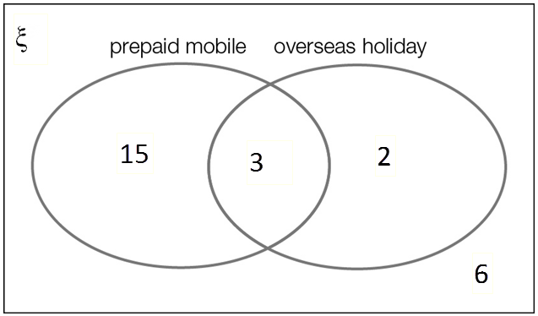

**(c)** **(i)** Pr(prepaid mobile phone) =  = 

**(ii)** Pr(prepaid mobile phone and overseas holiday) = 

**(iii)** Pr(no overseas holiday) = 

**(d)** Pr(prepaid mobile knowing overseas holiday) = 

Question 19 10 marks [8.5]

**(a)** mean =  ≈ 36.5 runs

0, 0, 0, 0, 0, 0, 0, 1, 2, 2, 3, 3, 11, 11, 13 | 17, 18, 19, 32, 32, 44, 44, 49, 69, 73, 81, 99, 141, 148, 182

median = 15 runs

range = 182 – 0 = 182 runs

**(b)** **(i)** Pr(score from 0 to 9) =  × 100% = 40%

**(ii)** Pr(at least 50) =  × 100% ≈ 23%

**(iii)** Pr(at least 100) =  × 100% = 10%

Extended answer total marks: 32

TOTAL test marks: 77